AC3 Decoder Spec

Created by Liu Huaping

1. AC3 Codec Introduction

The AC3 digital compression algorithm can encode for 1 to 5.1 channels of source audio from a PCM representation into a serial bit stream at data rates ranging from 32kbps to 640kbps. The 0.1 channel refers to a fractional bandwidth channel intended to convey only low frequency (subwoofer) signals.

A typical application of the algorithm is shown in Figure 1.1. In this example, a 5.1 channel audio program is converted from a PCM representation requiring more than 5Mbps (6 channels × 48 kHz × 18 bits = 5.184 Mbps) into a 384 kbps serial bit stream by the AC-3 encoder.

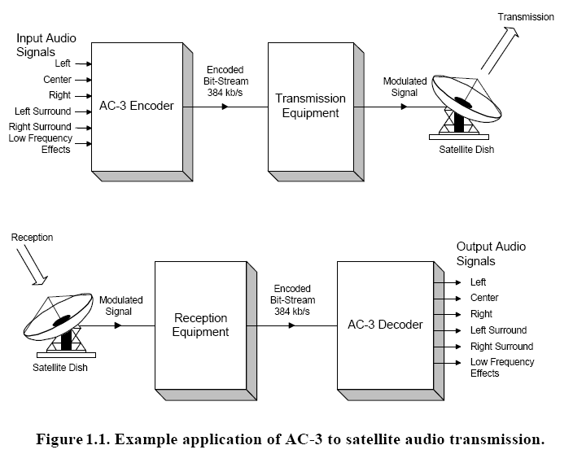

2. AC3 Decoder processing

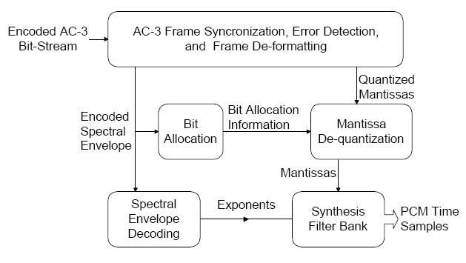

Figure 1.2. The AC-3 Decoder

1. AC3 Bit stream Syntax

1). Synchronization frame

An AC-3 serial coded audio bit stream is made up of a sequence of synchronization frames (see Figure 1.3.). Each synchronization frame contains 6 coded audio blocks (AB), each of which represents 256 new audio samples. A synchronization information (SI) header at the beginning of each frame contains information needed to acquire and maintain synchronization. A bit stream information (BSI) header follows SI, and contains parameters describing the coded audio service. The coded audio blocks may be followed by an auxiliary data (Aux) field. At the end of each frame is an error check field that includes a CRC word for error detection. An additional CRC word is located in the SI header, the use of which is optional.

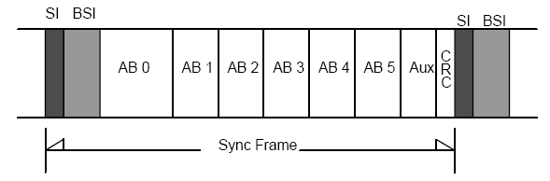

Figure 1.3. AC3 Synchronization Frame

2). SI --- synchronization Information

Syncword(16bits)

The syncword is always 0x0B77, or ‘0000 1011 0111 0111’. Transmission of the syncword, like other bit field elements, is left bit first.

Crc1(16bits)

This 16 bit-CRC applies to the first 5/8 of the frame. Transmission of the CRC, like other numerical values, is most significant bit first.

Fscod(2bits)

This is a 2-bit code indicating sample rate according to Table 1.1. If the reserved code is indicated, the decoder should not attempt to decode audio and should mute.

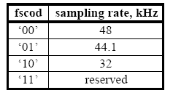

Table1.1 Sample Rate Code

Frmsizecod(6bits)

The frame size code is used along with the sample rate code to determine the number of (2-byte) words before the next syncword.

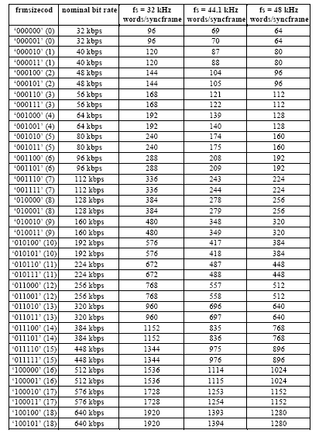

3) Bsi --- Bit Stream Information

For more information, refer to the AC3 standards spec : ATSC_A52.pdf

1. Visualon AC3 decoder software release note
2. You can get the “Dolby Digital Decoder for Portable Solutions implementation Development Kit” --- CD1 and “Dolby Portable Solution implementation Development Kit” --- CD2, meanwhile you can get the Codec Certification pass report from Dolby.

Docs Directory: ../ trunk/Codec/Audio/AC3/DECODER/spec

1. APIs Description

Following SDK3.0 APIs

1. SetParam IDs Description

***VO_PID_AC3_WORDSIZE***:

Output PCM sample bits, Now only support 16-bit interger, but you can update these code, and support 17 ~ 32 bits

If(wordsize == 0)

Support 16bits PCM output

Else if (wordsize == 1)

Support 32bits PCM output

else

Support 17~24bits PCM output

***VO_PID_AC3_KCAPABLEMODE:***

Karaoke capable reproduction mode

0 = no vocal

1. = left vocal
2. = right vocal
3. = both vocal (default) --- Karaoke capable mode

***VO_PID_AC3_DRCMODE:***

Compression mode out of range

Default: 2 --- line out

***VO_PID_AC3_OUTLFEON:***

Output subwoofer present flag

Default: 1 --- On

***VO_PID_AC3_OUTPUTMODE:***

Output channel configuration

Default: 2 --- L, R

***VO_PID_AC3_NUMCHANS:***

Output channel number

Default: 2 --- 2 channels

***VO_PID_AC3_STEREOMODE:***

Downmix Type, if you want to enable the ID, you have to set p_confparam->outputmode == 2 firstly

1. = Lt/Rt
2. = Lo/Ro

**VO_PID_AC3_DUALMONOMOD:**

Dual mono reproduction mode

***VO_PID_AC3_USEVERBOSE:***

Verbose message flag

It only bring into correspondence with the standerds algorithm, have not usefull for appilication

**VO_PID_AC3_DYNX:**

Dynamic range scale factor(high)

Default(0x7FFFFFFF)

***VO_PID_AC3_DYNY:***

Dynamic range scale factor(low)

Default (0x7FFFFFFF)

***VO_PID_AC3_OUTPUTFLAG:***

Output PCM flag

Set 1, enable dump PCM data, and Set0, disable dump PCM data

***VO_PID_AC3_CHARI:***

Channel routing information, Default: -0L -1R -2C -3l -4r -5s